About the substance
Name of substance
Hazardous ingredient
What is the work activity
Who uses it/exposed to it
How often is it used
How should it be stored
How is it be disposed of
Nature of the Risk
Chemical Flammable Poisonous Biological Carcinogen
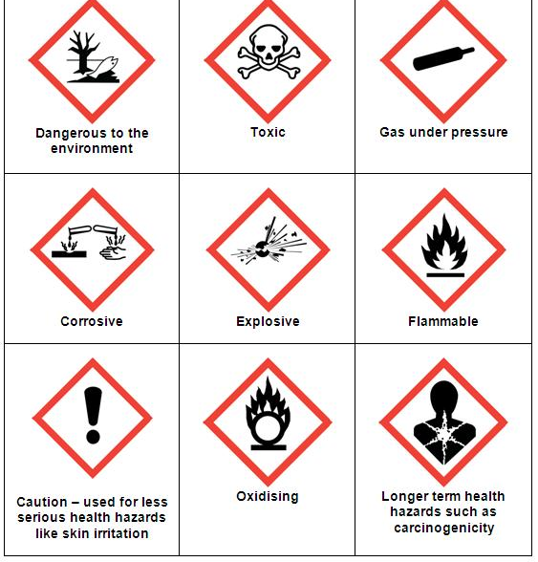
Health Effects
What will happen if exposed | Eyes
 | Skin
 | Inhalation
 | Ingestion
First aid measures | Eyes
 | Skin
 | Inhalation
 | Ingestion
Control measures | Eyewear Gloves Facemask
Other
Ventilation | General Local
Health monitoring
Staff Training
Emergency Action:

